Sulz am Neckar, Juni 2022

Universal and flexible:
New Multi-clamping system – system width 50

HEINRICH KIPP WERK has launched a new multi-clamping system that enables reliable clamping of diverse workpieces. It is suitable for all batch sizes and permits very high clamping forces. The precision toothing of the system ensures precise repeat accuracy. Furthermore, the conversion from single to multi-clamping can be carried out quickly and easily.

The multi-clamping system consists of variable elements: clamping rails, stops and wedge clamps (with or without fixed jaw) can all be combined with each other. The clamping rails are available in lengths of 130, 300, 400, 500, 600 and 700 mm. The clamping length range can be flexibly extended by mounting several clamping rails in series. By mounting side by side, the clamping area can be widened so that large components can be clamped.

Basically, the double-sided wedge clamp models with fixed jaws enable single-sided clamping. The precision toothing ensures highly accurate positioning of the fixed jaws so that they can be fastened securely and precisely. When the fastening screw is tightened, a positive connection is achieved between the rail and wedge clamp.

Fixed jaws are available in smooth, serrated and stepped designs. The type ES is characterised by its narrow design and is therefore ideal for clamping smaller workpieces and larger batch volumes. Type DS fixed jaws with two fastening screws are preferred where higher machining forces are involved.

Clamping rails can be attached via various interfaces. They have a lateral clamping rim for clamping claws, which can be attached at any position. In addition, clearance holes for standard cap screws and locating holes for conventional zero point clamping systems with pitch spacings of 96 mm and 200 mm are provided. Mounting via alignment keyways for T-slot tables as well as locating holes for grid systems with hole spacings of 40 mm and 50 mm is also possible.

Users of the new multi-clamping system from KIPP also benefit from an extensive range of accessories. Rest ledges, various attachment jaws and workpiece stops amongst other things are available.

(Characters including spaces: 2,286)

Image overview:
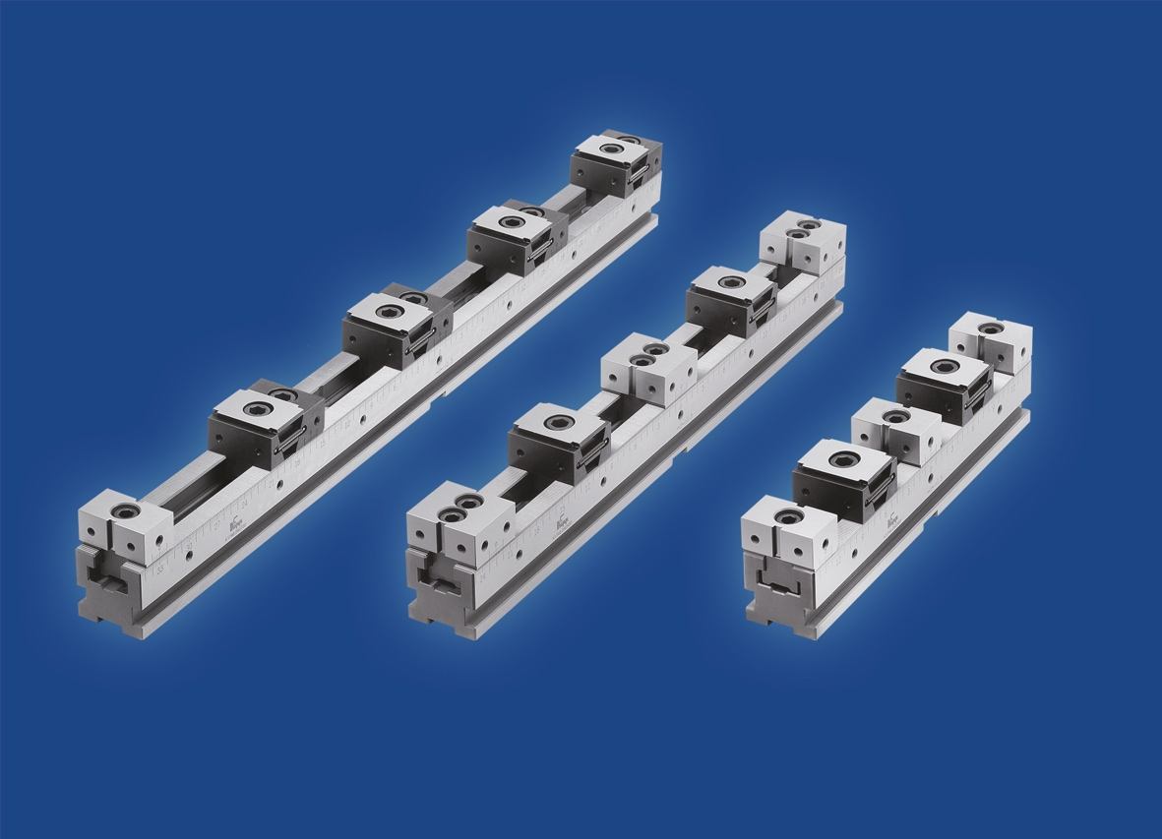
HEINRICH KIPP WERK has launched a new multi-clamping system to the market,
with a system width of 50.

Deeplinks:
https://www.kippwerk.de/de/de/News/KIPP-News/Neues-Mehrfach-Spannsystem-der-Systembreite-50.html

https://www.kippwerk.de/de/de/Produkte/Spanntechnik/Schraubstock-Spanntechnik/Mehrfach-Spannsystem.html

Other information and press photos
See www.kipp.com, Region: Germany, Category: News/Press section

Meta-Title: New multi-clamping system with system width 50

Meta-Description: HEINRICH KIPP WERK has launched a new multi-clamping system to the market which enables the clamping of workpieces of various sizes.

Keywords: KIPP, HEINRICH KIPP WERK, multi-clamping system, wedge clamp, clamping, multi-clamping, stops, fixed jaws, clamping technology

Download-Area:
https://www.kippwerk.de/de/de/Download/Pressebereich.html

HEINRICH KIPP WERK GmbH & Co. KG
Stefanie Beck, Marketing
Heubergstrasse 2
72172 Sulz am Neckar

Telephone: +49 7454 793-30
Email: stefanie.beck@kipp.com

Press Office:
Köhler + Partner GmbH
Brauerstrasse 42 • 21244 Buchholz i.d.N.
Telephone +49 (0) 4181 92892-0 • Fax +49 (0) 4181 92892-55
info@koehler-partner.de • www.koehler-partner.de

