Sulz am Neckar, November 2021

KIPP creates a platform for combination
top-level sports and training

In future, HEINRICH KIPP WERK will promote young Olympic talent from Baden-Württemberg. As a partner organisation of top-level sport, the company will support young athletes as a training facility - offering a special form of dual career that enables competitive sport and a career to be combined.

Technical and commercial training, dual studies, practical semesters, Bachelor and Master theses as part of university study programmes - all this can be envisioned and arranged at KIPP. To kick off the cooperation, Charlotte Gallbronner, a promising young German biathlon talent, visited the HEINRICH KIPP WERK in Sulz am Neckar. She was not alone during her visit; Kristin Redanz, the managing director of the Stiftung Olympianachwuchs (Olympic Youth Foundation) from Stuttgart, also came along. Nicolas Kipp, who runs the company in the fourth generation together with his father Heinrich Kipp, exchanged views with the visitors about the daily training and school routine of top athletes.

Karl-Josef Rebmann, responsible for organisation and personnel at KIPP and member of the Managing Board of Directors, appreciates this kind of cooperation and has gained a wealth of experience in working with top athletes and the Olympic Training Centre for more than a decade. He was able to accompany numerous athletes and is enthusiastic about the professional organisation. They, in turn, appreciate the opportunity to reconcile a sporting career and vocational training.

KIPP is a committed sponsor and partner company to top-level sport - this is also of benefit to the local community. For example, as part of physical education classes for schools, sports sessions with the future top athletes are being planned. .Ralf Kauffer, responsible for human resources at HEINRICH KIPP WERK, is looking forward to meeting the future trainees and cooperative students. He, too, would like to provide the region with "a touch of top-class sport".

(Characters including spaces: 2,002)

Image overview:

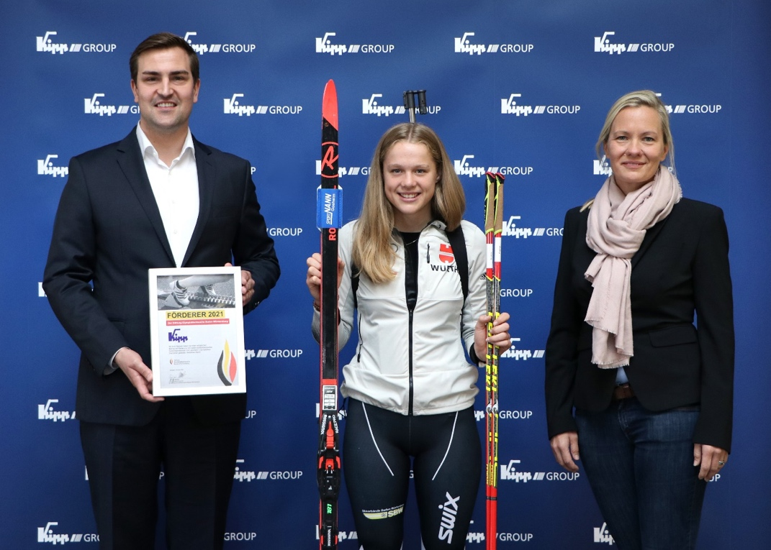
A touch of top-level sport at KIPP: German biathlon talent Charlotte Gallbronner and Managing Director of Stiftung Olympianachwuchs Kristin Redanz, with company owner Nicolas Kipp.

Deeplinks:
www.kipp.com

HEINRICH KIPP WERK GmbH & Co. KG
Stefanie Beck, Marketing
Heubergstrasse 2
72172 Sulz am Neckar

Telephone: +49 7454 793-30
Email: stefanie.beck@kipp.com

